Systems Analysis and Modeling Technique: County Library Registration System

Michael
Trident University
ITM 426 Systems Analysis and Design
Dr. Mohammad Abdel-Rahman
November 8th, 2025

Systems Analysis and Modeling Technique: County Library Registration System
Modern library systems are complicated information infrastructures that encompass the user administration, resource catalogization, circulation control and administration. The county library registration system is an example of how the modern information systems can be used to facilitate the interaction between the patrons and also the internal operations in a well thought out data management architectures. In the current paper, the concepts of functional dependency diagrams (FDD) and data flow diagrams (DFD) are used to describe a typical county library system and discuss how both methodologies can help to uncover the complex interrelationships between system components and stakeholder interactions (Siau et al., 2022).
System Analysis and Data Sources
Primary Entities Identified
The library registration system has four major categories of entities. The patron entities are different groups of users such as adults, students, educators, researchers, and children who have different access levels and borrowing parameters. The student clientele can have access to long loan periods on educational resources, and the children accounts will use parental restrictions and filters on their accounts. Adult customers have access to special services such as digital databases and inter-library loan services that other categories do not have.
Examples of resource entities include physical books, audiobooks, digital materials, periodicals and special collections all of which need specific metadata management. Digital material poses some specific complexity as it requires monitoring of the licensing restrictions, users simultaneously, format variations, and the accessibility facility along with the customary subject divisions. This collection management hybrid complicates the systems to ensure uniformity of availability information on a variety of forms of the same title.
The staff groups, i.e., librarians, circulation staffs and administrators, have access controls based on hierarchical levels according to their operational responsibilities. The circulation clerks handle low-level check out operations and limited information about patrons whereas the system librarians enjoy privileged access to maintain the catalogs, extensive reporting, and system setup. All interactions of the system are stored as transaction entities that include checkouts, returns, renewals, holds, fines, payment, and generate audit trails that are of vital importance in operational reporting and accountability (GeeksforGeeks, 2025).
Data Flow Analysis
Information is processed in the library system in interrelated pathways of classical systems analysis concepts. Registration of patrons triggers data operations establishing links between demographic data, account privileges and system access controls. To register as a new patron, one needs to have his / her address verified, be relevant to the category, have a borrowing limit, and generate a library card as well as have his / her account set up.
The circulation processes and resource discovery establish dynamic data interactions among the patrons, staff, and catalog systems. Search queries activate multi-database functions: local catalog queries would reveal physical availability, external databases would reveal more materials, and patron records would allow issuing a personal recommendation based on the borrowing history. Such a combination is the example of the complexity of the modern information retrieval systems (Lucidchart, 2024).
Online account management, administrative reporting features, bring new complexity to the digital integration. The definition of a real-time synchronization between online and physical systems prevents the occurrence of the situation when a resource is booked twice and preserves the same availability status of a resource among access channels. Administrative functions combine transaction data on various sources to produce usage analytics, collection development insights and operational reports that aide in making strategic decisions.
Functional Dependency Diagram
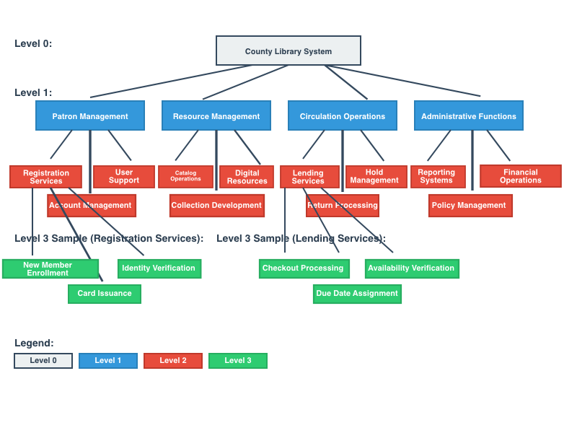
Figure 1: Functional Dependency Diagram
The functional dependency diagram is a hierarchical view of the county library system as a three-level decomposition of the system according to the principles of systems decomposition (Abdelrahman, 2015). Level 0 describes the entire library operation as it is seen by the outside stakeholders. The decomposition of this at Level 1, into four broad business functional areas, namely, Patron Management, Resource Management, Circulation Operations and Administrative Functions depict different business processes that have different responsibilities and data dependencies.
Level 2 information that supports operations that facilitate primary services. Patron Management includes Registration Services, Account Management and User Support. Registration Services also goes down to member enrollment, issuing and verifying identity. Such a hierarchical structure illustrates the way in which complex library management functions can be broken down into manageable parts exposing the best automation opportunities and points of system integration.
Context Diagram
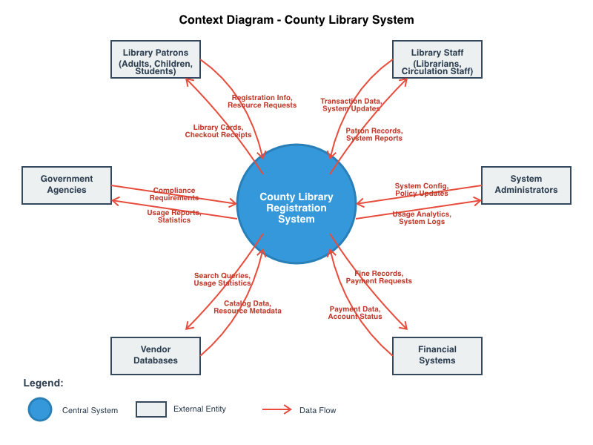
Figure 2: Context Diagram
The context diagram determines the boundaries of the library system and the interaction between the external entities and the stakeholder groups that have special information needs (Visual Paradigm, n.d.). The central system interacts with six major external parties, who include Library Patrons who are requested to submit registration information, request resources, and payments and get library cards, checkout, and account notifications. This two-way process depicts two-way patron-system interactions.
The Library Staff members will enter transaction and system update data and retrieve patron records and operational reports as both data contributors and consumers. System Administrators use parameters and policies to manage and oversee usage analytics and performance indicators. Financial Systems exchange payment information and account balances, demonstrating integration requirements with external accounting systems. Supplier Databases give updates of vendors and metadata of resources and obtain search requests and usage statistics, which shows a reflection of collaborative library networks. Government Agencies have compliance reports and use statistics and provide regulatory requirements, which depict the balance between service delivery and regulatory compliance to the public libraries.
Data Flow Diagram - Level 0
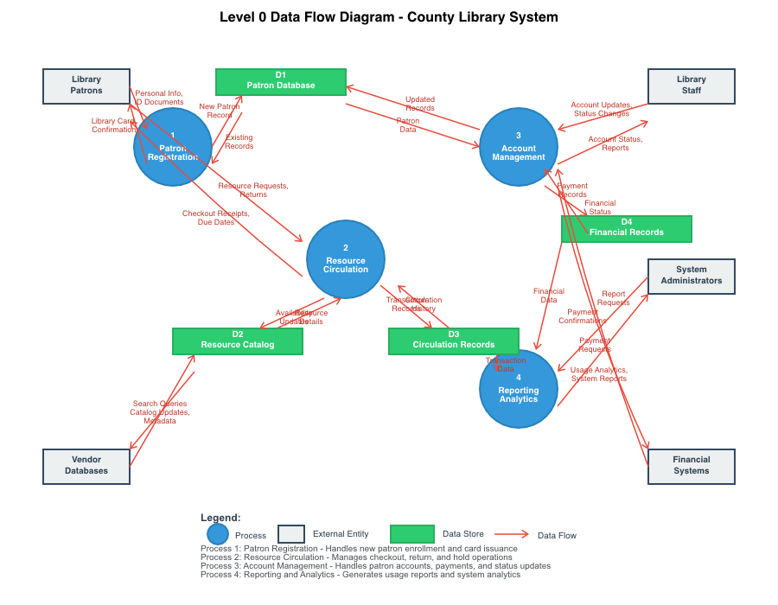
Figure 3: Level 0 Data Flow Diagram
Level 0 DFD breaks down the library system and results in four inter-related processes that make use of data stores and external entities (GeeksforGeeks, 2025).
Process 1: Patron Registration: This process deals with the registration, identification and issuance of a card, and this process interacts with the Patron Database (D1), to convert unstructured patron data into system records defining access privileges.
Process 2: Resource Circulation manages checkout, return, and hold with access to the Resource Catalog (D2) and Circulation Records (D3), which characterizes complex relationships with the need to update data stores simultaneously in order to maintain consistency within the system.
Process 3: Account Management Patron account, payments and status updates This process with assistance of Patron Database (D1) and Financial Records (D4) is an example of cross-functional data integration, a circulation activity initiates an update of account status with information about financial calculations and payment processing.
Process 4: Reporting and Analytics generates system reporting and analytics used to summarize transaction data across multiple stores, providing administrators with usage information to assist in collection development and strategic planning decisions.
System Design Assumptions
This analysis assumes some major operational assumptions. Physical and physical resources are handled through the system, and they should be dealt with integrated strategies. Upon receiving patrons' material orders, the system inquires about what is available in all forms —physical, digital, audiobook —considering format options and licensing limitations. Strong access controls and audit data will be used in privacy and security of patron data. Role-based access will be used to access to individual financial histories of patrons, but the collection development librarians will be allowed to view the anonymous usage statistics.
Conclusion
As demonstrated in this thorough discussion, functional dependency charts and data flow charts can be helpful in modeling the complexity of contemporary library activities. The hierarchical decomposition reveals the structural association among system elements, as data flow diagrams depict the order of information flow and changes. The county library registration system is a complicated information infrastructure and can be organized by analyzing the relationships between the functions and data dependencies, promotes community education, research, and cultural enrichment, and responds to the challenge of the digital revolution and change in user expectations.

References
Abdelrahman, O. H. (2015). Analysis of the University of Khartoum Library System using the Structured Systems Analysis and Design Methodology (SSADM). Cybrarians Journal, (38). https://www.researchgate.net/publication/280805244
GeeksforGeeks. (2025, July 15). DFD for Library Management System. https://www.geeksforgeeks.org/dfd-for-library-management-system/
Lucidchart. (2024, November 4). What is a data flow diagram. https://www.lucidchart.com/pages/data-flow-diagram
Siau, K., Woo, C., Storey, V. C., Chiang, R. H., Chua, C. E., & Beard, J. W. (2022). Information systems analysis and design: Past revolutions, present challenges, and future research directions. Communications of the Association for Information Systems, 50, 263-293. https://doi.org/10.17705/1CAIS.05012
Visual Paradigm. (n.d.). Data flow diagram: Examples - food ordering system. https://www.visual-paradigm.com/tutorials/data-flow-diagram-example-food-ordering-system.jsp

